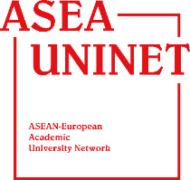

ASEA UNINET WORKSHOP INDONESIAN CHAPTER
6—8 November 2017, at Universitas Indonesia, Depok Campus
REGISTRATION FORM

- Personal Information
Title :
Name :
Nationality :
Gender :
Date of Birth :
Gender : Male/Female
Institution :
Position :
Passport No :

- Contact Information
Phone Number :
Email :
Address :

- Presentation on Panel Session
Title of Presentation :
Approach of the Presentation/research : (example: health, economy, etc)

- Dietary Restriction
Food/dietary Restriction :

- Flight Details
Arrival at Soekarno-Hatta International Airport:
Date :
Arrival Time :
Airlines Name :
Flight No :

Departure from Soekarno-Hatta International Airport:
Date :
Arrival Time :
Airlines Name :
Flight No :

- Hotel Reservation (The Margo Hotel, Depok)
Check in Date : Check out Date:
Do you need a confirmation letter on your name? Yes/No
Room type : Single/twin (if you choose twins, colleague’s name to share the room with is ..........................)

Note: Rate for one room (single/double) is IDR 907.000

- Participation on Excursion to The Old Batavia, Indonesian National Museum, and Bank Indonesia Museum on 8 Dec:

Yes/ No

- NOTE/Special Request:
____________________________________________________________________________________________________________________________________________________________________________________________________________________________________________________________________________________

